**Assignment 2**

Name: Jain Samkitkumar Hasmukhlal

Class: TEIT Roll. No.: 20 Batch: T1

Write a program in PHP/ python/Java/.net to access stored procedure and functions using ODBC/JDBC.

package javaapplication;

import com.mysql.jdbc.Connection;

import com.mysql.jdbc.Statement;

import java.sql.CallableStatement;

import java.sql.DriverManager;

import java.sql.ResultSet;

import java.io.*;

import java.sql.Types;

/**

* @author Samkit

*/

public class JavaApplication {

/**

* @param args the command line arguments

*/

private CallableStatement clmt;

public Connection getConnection1()

{

Connection con=null;

try{

Class.forName("com.mysql.jdbc.Driver");

con=(Connection)DriverManager.getConnection("jdbc:mysql://localhost:3307/test" , "root", "mysql");

}

catch(Exception e)

{

System.out.println("Error in Connection"+e);

}

return con;

}

public void getCustomer()

{

try{

Connection con=getConnection1();

Statement st=(Statement) con.createStatement();

ResultSet res=st.executeQuery("select * from customer");

while(res.next())

{

System.out.print(res.getString(1)+" ");

System.out.print(res.getString(2)+" ");

System.out.print(res.getString(3)+" ");

System.out.println(res.getString(4)+" ");

}

res.close();

con.close();

}

catch(Exception e)

{

System.out.println("Error in fetching data");

}

}

public void callProcedure1()

{

try{

Connection con=getConnection1();

clmt = con.prepareCall("{call proc1}");

ResultSet res=clmt.executeQuery();

if(res.next())

{

System.out.println(res.getString(1));

}

}

catch(Exception e)

{

e.printStackTrace();

}

}

public void callProcedure2()

{

try{

Connection con=getConnection1();

clmt=con.prepareCall("{call proc2}");

ResultSet res=clmt.executeQuery();

while(res.next())

{

System.out.println(res.getString(1)+ "\t" +res.getString(4));

}

}

catch(Exception e)

{

e.printStackTrace();

}

}

public void callProcedure3(String code,String name)

{

try{

Connection con=getConnection1();

clmt=con.prepareCall("{call proc3(?,?)}");

clmt.setString(1,code);

clmt.setString(2,name);

int i=clmt.executeUpdate();

if(i!=0)

System.out.println("Inserted Successfully");

else

System.out.println("Not Inserted");

}

catch(Exception e)

{

e.printStackTrace();

}

}

public static void main(String[] args) {

// TODO code application logic here

JavaApplication obj=new JavaApplication();

obj.getCustomer();

obj.callProcedure1();

obj.callProcedure2();

obj.callProcedure3("123","samkit");

}

}

Database (MySQL):

mysql> use test;

Database changed

mysql> create table customer(custid varchar(20)primary key,custName varchar(30),

custAddr varchar(50),custContact varchar(20));

Query OK, 0 rows affected (1.10 sec)

mysql> insert into customer values('a10',’akshay','pune','4566');

Query OK, 1 row affected (0.22 sec)

mysql> insert into customer values('a101','samkit','pune','1234');

Query OK, 1 row affected (0.22 sec)

mysql> insert into customer values('a102','aish','pune','4566');

Query OK, 1 row affected (0.06 sec)

mysql> insert into customer values('a103','chandini','pune','4566');

Query OK, 1 row affected (0.03 sec)

mysql> create table Emp(code varchar(10) primary key,name varchar(30)null,city varchar(20),salary int);

Query OK, 0 rows affected (0.28 sec)

mysql> insert into Emp values('a101','samkit','pune',10000);

Query OK, 1 row affected (0.07 sec)

mysql> insert into Emp values('a102','aish','pune',10000);

Query OK, 1 row affected (0.03 sec)

mysql> insert into Emp values('a103','chandini','pune',10000);

Query OK, 1 row affected (0.03 sec)

mysql> insert into Emp values('a10','akshay','pune',10000);

Query OK, 1 row affected (0.03 sec)

**Procedure 1**

mysql>

mysql> delimiter $$

mysql> create procedure proc1()

-> begin

-> select avg(salary) as salary from Emp;

-> end;

-> $$

Query OK, 0 rows affected (0.30 sec)

mysql> delimiter ;

mysql> call proc1();

+------------+

| salary |

+------------+

| 10000.0000 |

+------------+

1 row in set (0.19 sec)

Query OK, 0 rows affected (0.20 sec)

**Procedure 2**

mysql> delimiter $$

mysql> create procedure proc2()

-> begin

-> select * from Emp;

-> end;

-> $$

Query OK, 0 rows affected (0.01 sec)

mysql> delimiter ;

mysql> call proc2();

+------+--------+-------+--------+

| code | name | city | salary |

+------+--------+-------+--------+

| a10 | akshay | pune | 10000 |

| a101 | samkit | pune | 10000 |

| a102 | aish | pune | 10000 |

| a103 | chandini | pune | 10000 |

+------+--------+-------+--------+

3 rows in set (0.00 sec)

Query OK, 0 rows affected (0.01 sec)

**Procedure 3**

mysql> delimiter $$

mysql> create procedure proc3(in code1 varchar(10),in name1 varchar(10))

-> begin

-> insert into Emp(code,name) values(code1,name1);

-> end;

-> $$

Query OK, 0 rows affected (0.01 sec)

mysql> delimiter ;

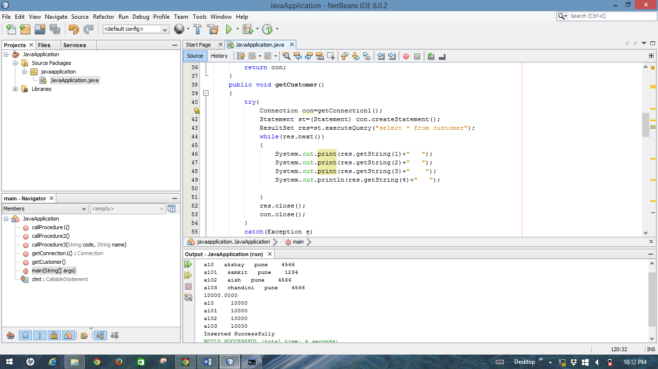

a10 akshay pune 4566

a101 samkit pune 1234

a102 aish pune 4566

a103 chandini pune 4566

10000.0000

a10 10000

a101 10000

a102 10000

a103 10000

Inserted Successfully